- Install the ALM Connectivity.
ALM Default page -> Tools -> HP ALM Connectivity

- Create an excel file specifying the users you want to move to Viewer role.
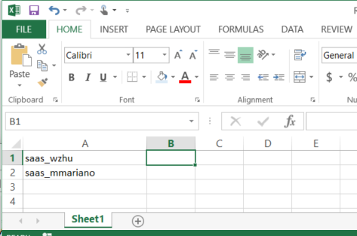

- Launch the tool and enter the server url. Click on Initialize Server.
- Authenticate by entering the user name and password. The user running the tool should be a TDAdmin or belong to a group with permission with user management. Click on Authenticate.
- Select the domain and project.
- Select “Move Users to Viewer” from the task lookup list.
- Specify the location where the tool will write log file.
- Click on Run.
- Specify the location where you saved the excel file in step 2.
- Click on Start.
